**Experiment No.:** 05

**Experiment Name:** Implementation of the Secant method.

**Theory:**

The **Secant Method** is a numerical technique used to approximate the roots of a nonlinear equation f(x)=0. Unlike the Newton-Raphson method, it does not require the derivative of the function, which makes it useful when derivatives are difficult or impossible to compute.

The method uses two initial approximations x0 and x1​, and constructs a secant line (a straight line connecting two points on the function curve). The root is approximated by the point where this line intersects the x-axis.

The iteration formula is:

xn+1 = xn − f(xn) ⋅

* **Initial guesses**: x0x_0x0​ and x1x_1x1​.
* **Stopping criteria**: Iteration stops when the difference between two successive approximations is less than a tolerance, or when ∣f(xn)∣ becomes sufficiently small.
* **Order of convergence**: The method has **super-linear convergence** (≈1.618), faster than Bisection but slower than Newton-Raphson.

**Program 1:** Programming Code

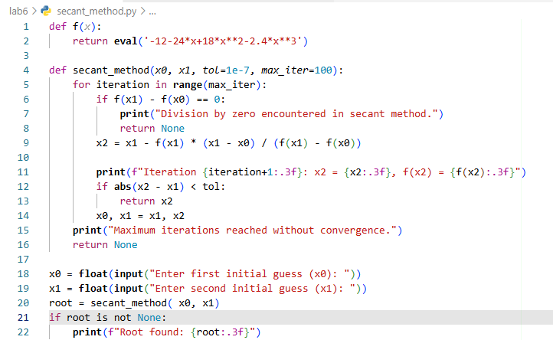

**Output:**

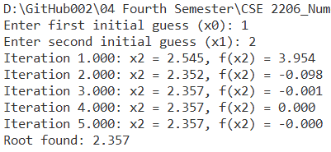

**Discussion & Conclusion**

The Secant Method is an effective iterative approach for solving nonlinear equations when derivative evaluation is difficult or inconvenient. By using two initial guesses, the method constructs a secant line to approximate the root. It generally converges faster than bracketing methods like Bisection or False Position, but slower than Newton-Raphson.

The accuracy and success of the method largely depend on the choice of initial guesses. Poorly chosen values may lead to divergence or division by a very small denominator. However, with proper starting points, the method provides good accuracy within a few iterations.

In conclusion, the experiment demonstrated that the Secant Method is a practical and efficient tool for root-finding, especially in engineering and scientific applications where derivatives are complex to obtain.